Angular Initial Setup

## Setp 1 : Install Node (LTS)

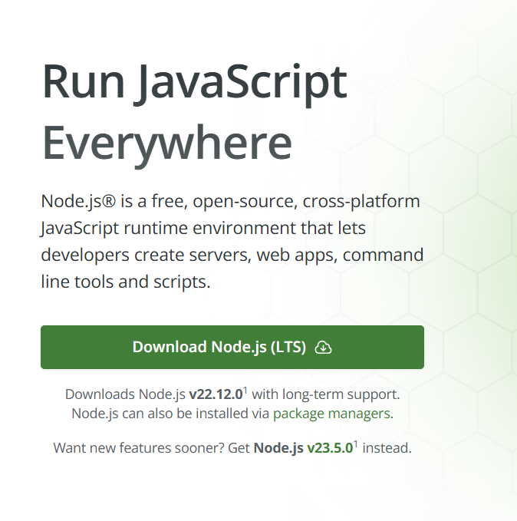

* After installing node should we should check that By ,

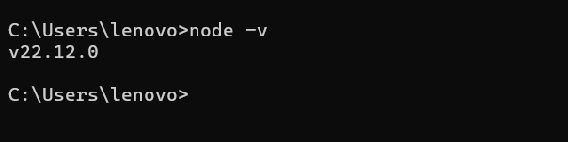

## Step 2 : Install Angular 18

* Open command prompt and type

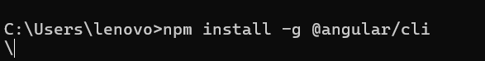

* Then check the installation is correct or not by,

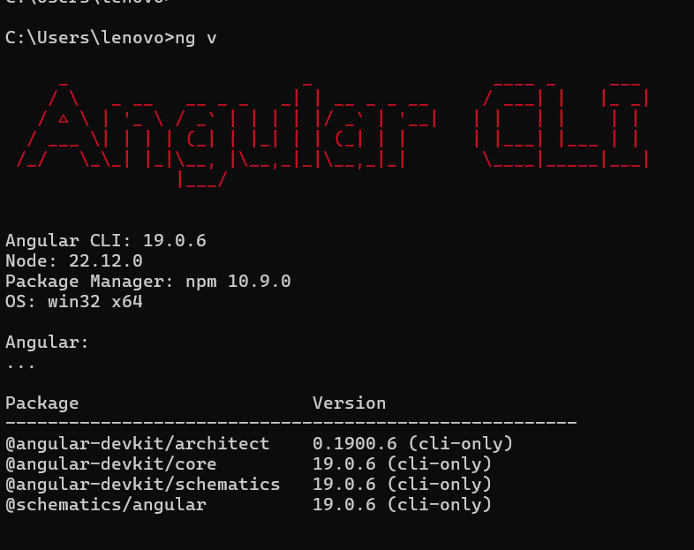

**Now the Installation is complete**

# Create new Project

## Step 1 : Open command prompt inside your folder :

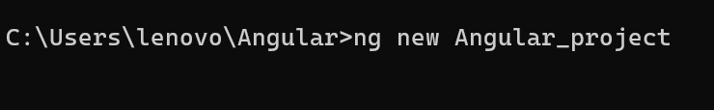

* Click enter by **selecting the css**

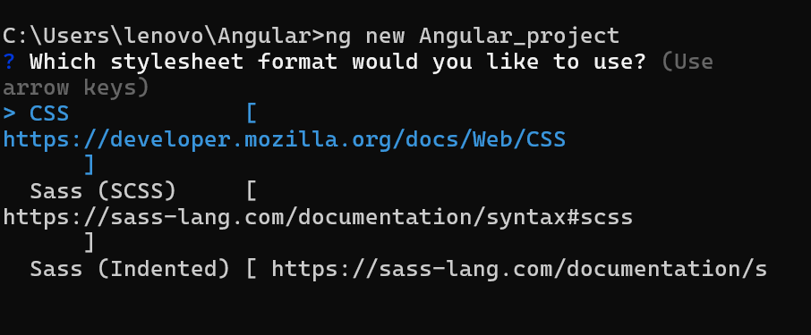

* Type y and enter for **enable the SSR**

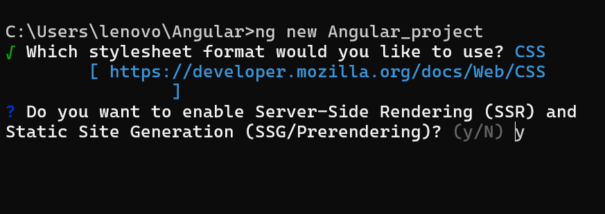

* For **getting routing** type y and enter

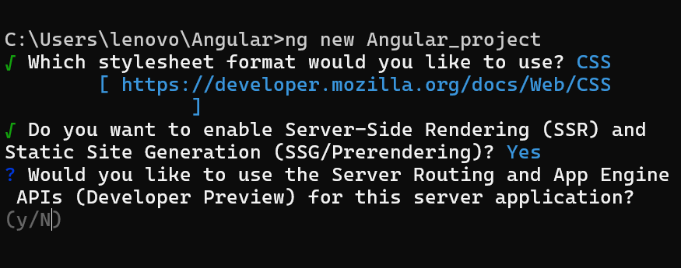

**Project creation is completed**

Now we can open the project in vs code ,

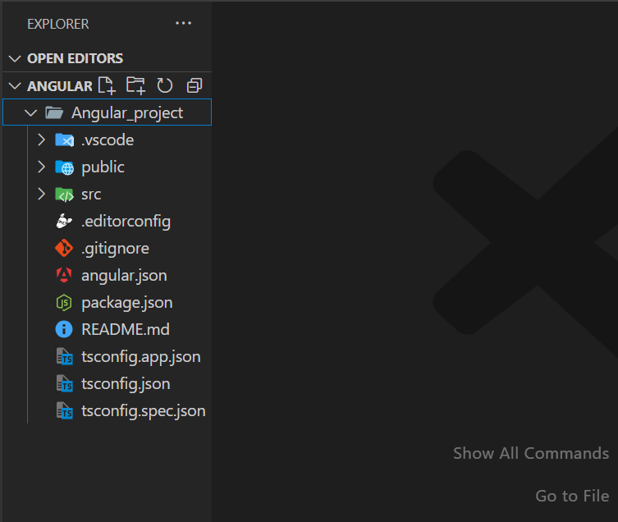

## Now run the Code ,

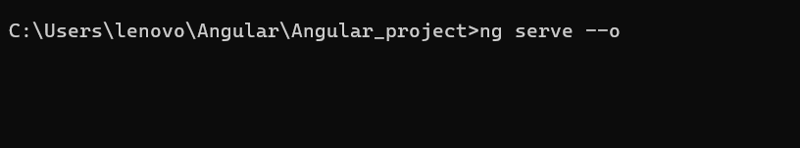

The initial screen should be ,

